

Foundations of Programming

Assignment No.: 18
PROBLEM STATEMENT: Write a C program that accepts a string from the user and performs the following string operations: i) Calculate length of string ii) String reversal iii) Equality check of two strings iv) Check palindrome v) Check substring.

OBJECTIVE:

- To understand basic string operations in C.
- To learn how to manipulate strings using loops and functions.
- To perform comparison, reversal, and substring checking.
- To check whether a string is a palindrome.

THEORY:
In C programming, a string is a sequence of characters terminated by a null character ('\0'). Strings are commonly stored in character arrays. Various operations can be performed on strings such as calculating their length, reversing the characters, comparing two strings, checking whether a string is a palindrome, and finding a substring within another string. These operations can be implemented using loops and conditional statements or by using standard library functions from the string.h header file.
PLATFORM: Linux
Algorithm:
- Start
- Input strings
- Find length
- Reverse string
- Check palindrome
- Compare strings
- Check substring
- Display results
- Stop
Code:
#include <stdio.h>

int main() {
char s1[100], s2[100], rev[100];
int len = 0, i, j, found = 0, isPalindrome = 1;

printf("Enter main string: ");
scanf("%s", s1);
printf("Enter string for equality/substring check: ");
scanf("%s", s2);

while (s1[len] != '\0') {
len++;
}
printf("\nLength of string = %d", len);

for (i = 0; i < len; i++) {
rev[i] = s1[len - 1 - i];
}
rev[len] = '\0';
printf("\nReversed string = %s", rev);

for (i = 0; i < len; i++) {
if (s1[i] != rev[i]) {
isPalindrome = 0;
break;
}
}
if (isPalindrome)
printf("\nThe string is a Palindrome");
else
printf("\nNot a Palindrome");

int equal = 1;
for (i = 0; s1[i] != '\0' || s2[i] != '\0'; i++) {
if (s1[i] != s2[i]) {
equal = 0;
break;
}
}
if (equal)
printf("\nStrings are equal");
else
printf("\nStrings are not equal");

for (i = 0; s1[i] != '\0'; i++) {
for (j = 0; s2[j] != '\0'; j++) {
if (s1[i + j] != s2[j]) break;
}
if (s2[j] == '\0') {
found = 1;
break;
}
}
if (found)
printf("\nSubstring found in main string\n");
else
printf("\nSubstring not found\n");

return 0;
}

INPUT: A string and another string for comparison and substring checking.

OUTPUT: Displays string length, reversed string, equality result, palindrome result, and substring check result.
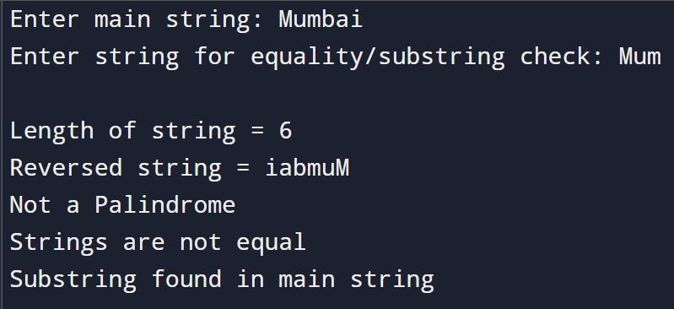

SAMPLE INPUT:

Enter a string: madam
Enter another string for equality check: mad
SAMPLE OUTPUT:
Length of string = 5
Reversed string = madam
The string is a Palindrome
Strings are not equal
Substring found in main string

CONCLUSION: Thus, the C program successfully performs different string operations such as length calculation, reversal, equality check, palindrome check, and substring detection.

FAQs:
- What is a string in C programming?
- Which header file is required for string functions?
- What function is used to find the length of a string?
- What is a palindrome string?
- Which function is used to check a substring in C?

